Satellite Certificate Renewal
- Security team will inform well in advance before the expiration of certificate.
- Need to raise a service request for security team for renewal. Refer REQ1070479
- Security team will provide Venafi link to download the certificate
- Login to the Venafi portal with SIC AD credentials and search for pdxlrhssp002
- Click on ActionsDownload
- 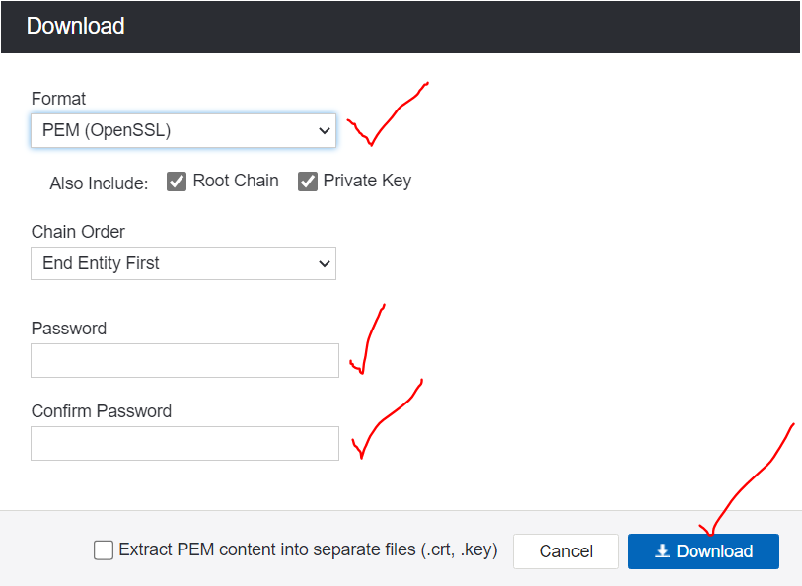
- Select the fields as per above snip and download.
- Transfer it to satellite server using winscp tool
- Move it to /root/satellite_cert/ directory
- Run the below commands –
[root@pdxlrhssp002 satellite_cert]# openssl rsa -in /root/satellite_cert/pdxlrhssp002.standard.com.pem -out /root/satellite_cert/satellite_cert_key.pem
Enter pass phrase for /root/satellite_cert/pdxlrhssp002.standard.com.pem:(enter the password created during the certificate download)
writing RSA key

[root@pdxlrhssp002 cert-renew]# satellite-installer --scenario satellite --certs-server-cert "/root/cert-renew/pdxlrhssp002.standard.pem" --certs-server-key "/root/cert-renew/satellite_cert_key.pem" --certs-server-ca-cert "/root/cert-renew/pdxlrhssp002.standard.com. --certs-update-server --certs-update-server-ca
2024-08-09 12:26:46 [NOTICE] [root] Loading installer configuration. This will take some time.
2024-08-09 12:26:49 [NOTICE] [root] Running installer with log based terminal output at level NOTICE.
2024-08-09 12:26:49 [NOTICE] [root] Use -l to set the terminal output log level to ERROR, WARN, NOTICE, INFO, or DEBUG. See --full-heor definitions.
Marking certificate /root/ssl-build/pdxlrhssp002.standard.com/pdxlrhssp002.standard.com-apache for update
Marking certificate /root/ssl-build/pdxlrhssp002.standard.com/pdxlrhssp002.standard.com-foreman-proxy for update
Marking certificate /root/ssl-build/katello-server-ca for update
2024-08-09 12:26:59 [NOTICE] [configure] Starting system configuration.
2024-08-09 12:27:13 [NOTICE] [configure] 250 configuration steps out of 2100 steps complete.
2024-08-09 12:27:21 [NOTICE] [configure] 500 configuration steps out of 2104 steps complete.
2024-08-09 12:27:23 [NOTICE] [configure] 750 configuration steps out of 2109 steps complete.
2024-08-09 12:27:25 [NOTICE] [configure] 1000 configuration steps out of 2112 steps complete.
2024-08-09 12:28:04 [NOTICE] [configure] 1250 configuration steps out of 2116 steps complete.
2024-08-09 12:30:17 [NOTICE] [configure] 1500 configuration steps out of 2116 steps complete.
2024-08-09 12:30:17 [NOTICE] [configure] 1750 configuration steps out of 2116 steps complete.
2024-08-09 12:30:31 [NOTICE] [configure] 2000 configuration steps out of 2116 steps complete.
2024-08-09 12:30:41 [NOTICE] [configure] System configuration has finished.
Success!
* Satellite is running at https://pdxlrhssp002.standard.com

* To install an additional Capsule on separate machine continue by running:

capsule-certs-generate --foreman-proxy-fqdn "$CAPSULE" --certs-tar "/root/$CAPSULE-certs.tar"
* Capsule is running at https://pdxlrhssp002.standard.com:9090

The full log is at /var/log/foreman-installer/satellite.log
Package versions are being locked.
[root@pdxlrhssp002 satellite_cert]# systemctl restart httpd
- Check the updated certificates on below path

[root@pdxlrhssp002 certs]# pwd
/etc/pki/katello/certs
[root@pdxlrhssp002 certs]# ll
total 56
-r--r-----. 1 root foreman 8804 Aug 9 12:27 katello-apache.crt
-rw-r--r--. 1 root root 1777 Jan 3 2017 katello-default-ca-stripped.crt
-rw-r--r--. 1 root root 5452 Jan 3 2017 katello-default-ca.crt
-rw-r--r--. 1 root foreman 8804 Aug 9 12:27 katello-server-ca.crt
-rw-r--r--. 1 root root 1481 Dec 22 2020 pdxlrhssp002.standard.com.crt
-rw-r--r--. 1 root root 7010 Dec 22 2020 pdxlrhssp002.standard.com.pem
-r--r-----. 1 root foreman 5398 Nov 17 2017 pulp-client.crt
[root@pdxlrhssp002 certs]#

